Open the "Foodmart_Data_Model.xlsx" worksheet that you saved on your desktop. This file was the finished product of your previous exercises. You should first complete all the other exercises and Quests before this one. If you just wrapped up the previous assignment, your view would probably look like the image below.

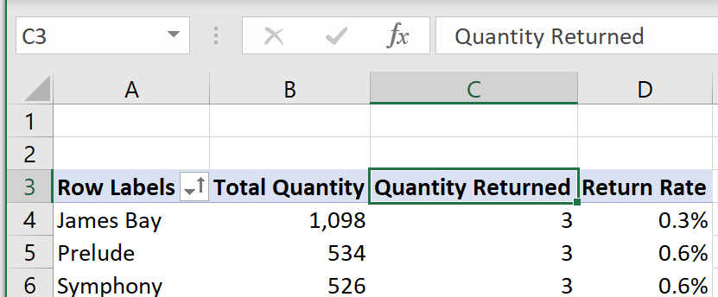

Now, take out the “Quantity Returned” column from the pivot table. You already know how to do this from a previous exercise. If you forget the step, drag the field out of the Values pane, or review the last assignment's detailed instructions.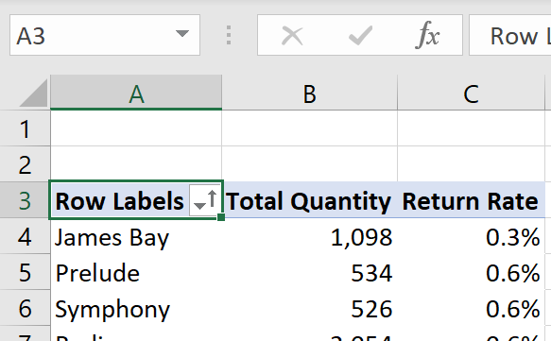

Rename the first column title from "Row Labels" to product_brand. You already have the knowledge and experience of changing field headers from previous work.

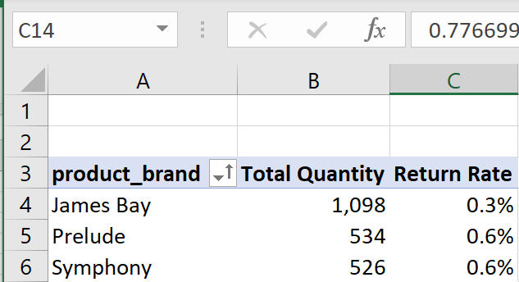



Sort in ascending order by product_brand. This process has been learned already from previous projects. Your new sorted pivot table will now look like the image below.

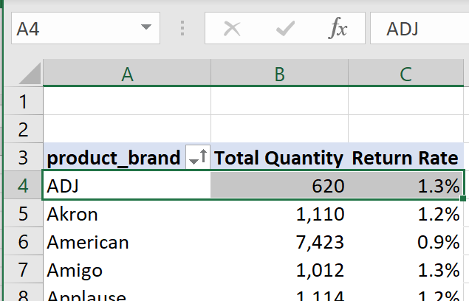



Create and check a new measure. Give it a name "Avg Retail Price" > assign it to Product_Lookup > give it a description > use currency format with two decimal places. You have already done a similar measure creation from a previous assignment.

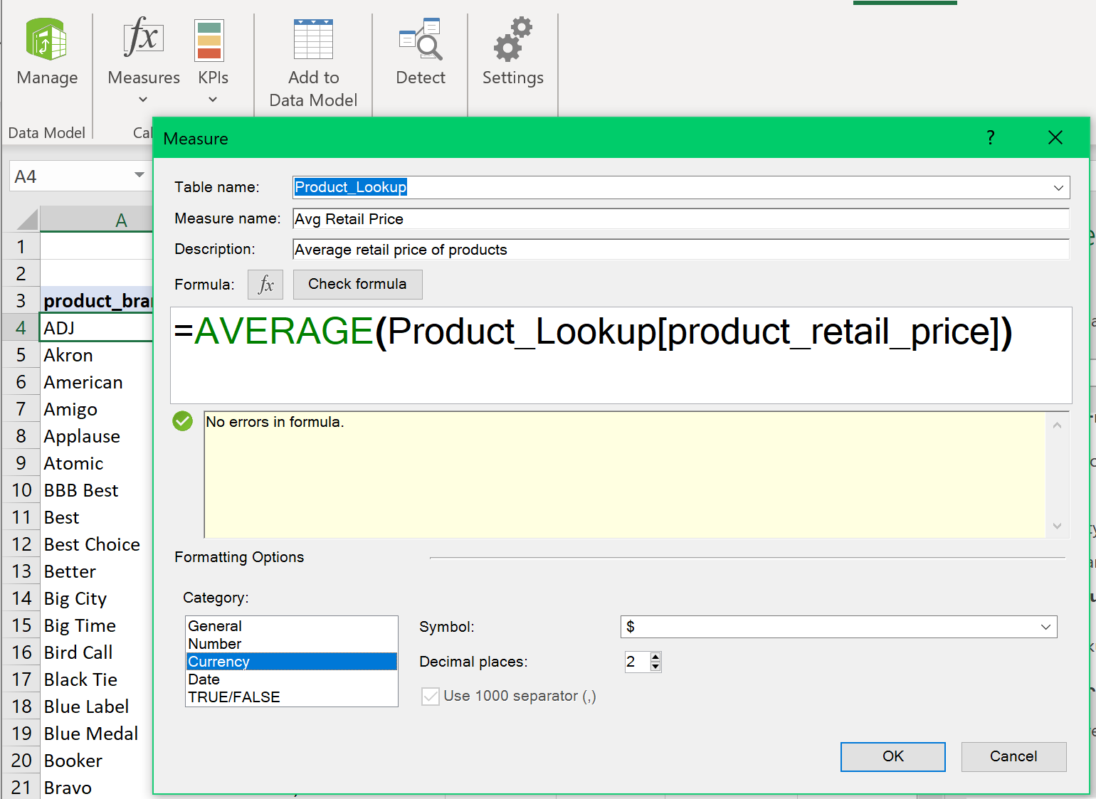



The newly created measure will be inserted at the bottom of your Values pane and rendered as the last column in your pivot table. If this is not done automatically, then drag "Avg Retail Price" from the Product_Lookup table to the Values section.

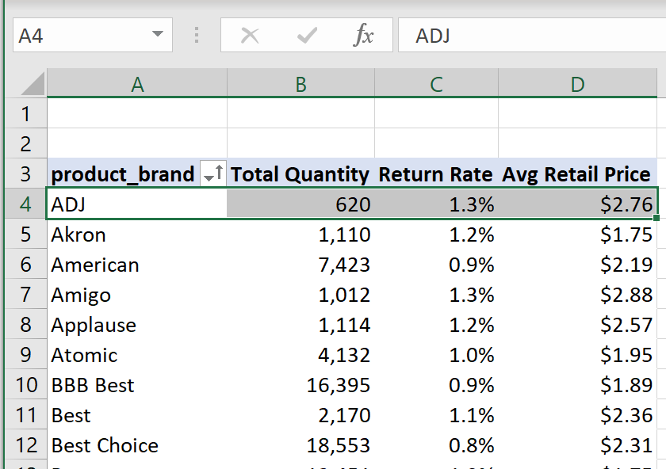 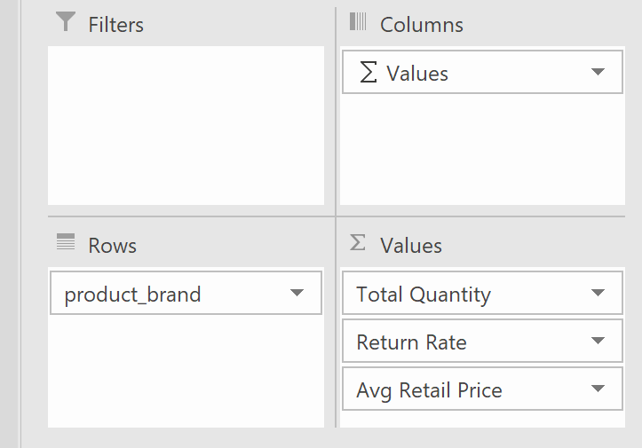



Create another measure called "Total Transactions" and assign it to the Transactions table. Use "Total number of rows in Transactions table" for description. Type and check the formula below > format as a whole number with thousand's separator.

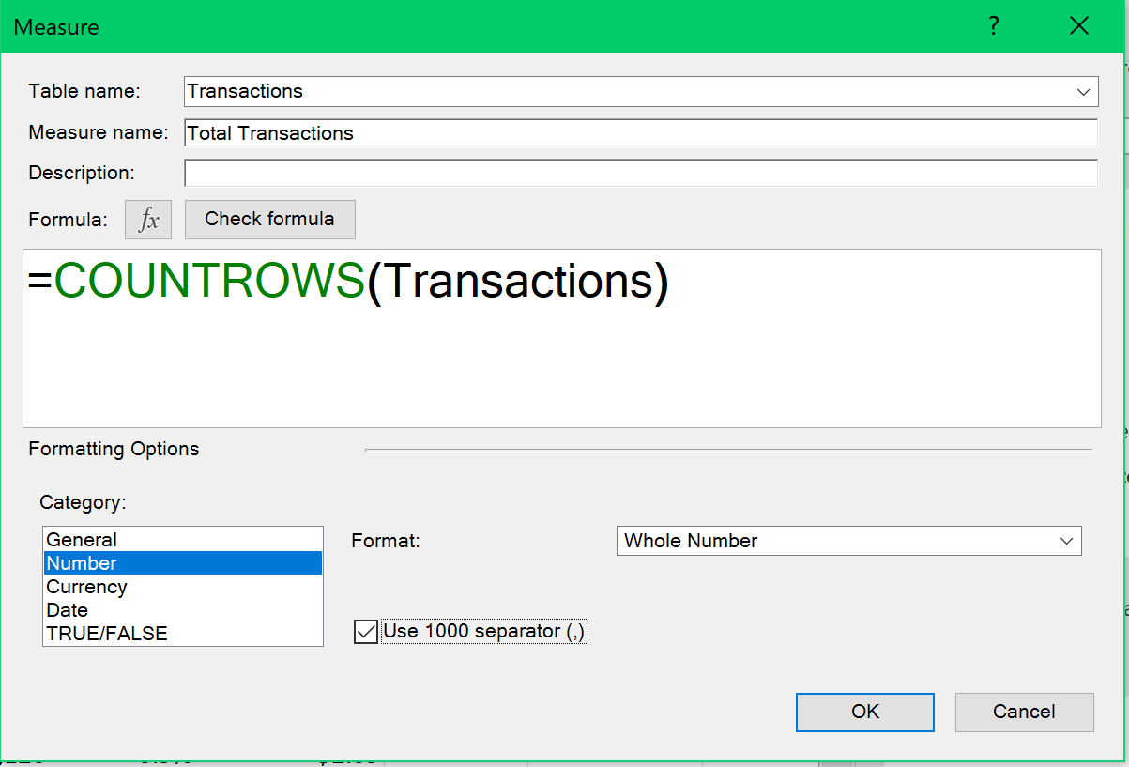



Your new pivot table should look like the below:

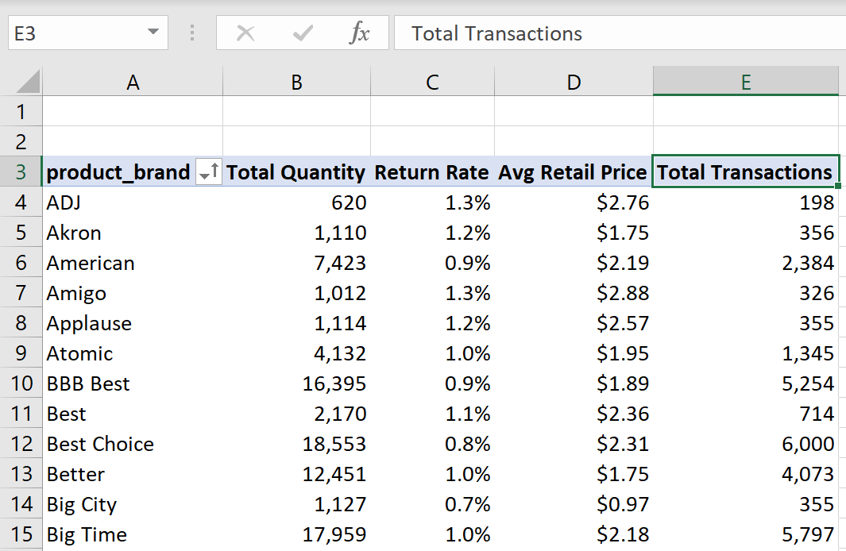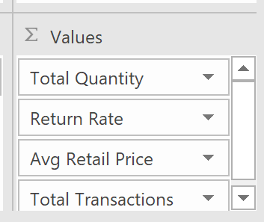



More next page . . .

This new measure's beauty is that the Transactions table is connected to all the lookup tables above it. Therefore, you may use any of the fields associated with those master tables as filter flows downstream. This means that later on, we can slice the count of total transactions using any of the attributes from the lookup tables because the transactions table is related to all of the above dimensional tables. You can see how this opens up many possibilities for analysis!

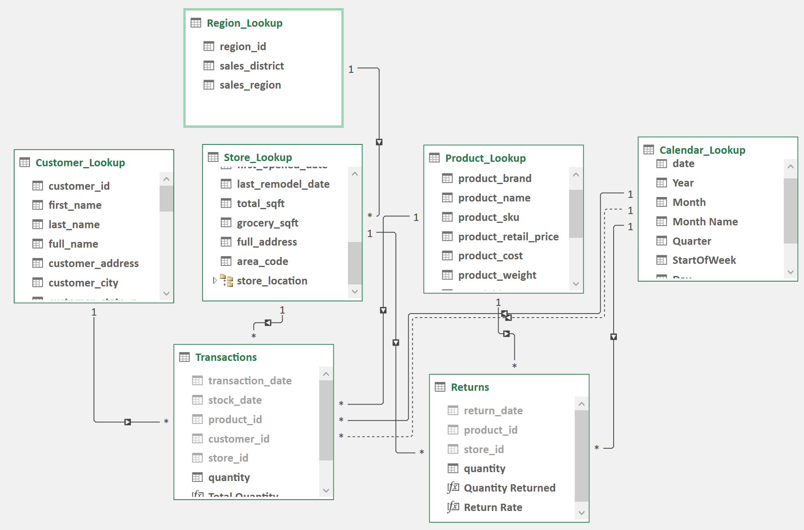



Now, let’s calculate the counts of unique products. Remember, you may press the Tab key to select the currently highlighted options in Power Excel. Give it a name “Unique Products” > assign to Product_Lookup table > count by Product_Lookup[product_id] using the fully-qualified column name > format as a whole number with comma separator for thousands > type and check the formula below.

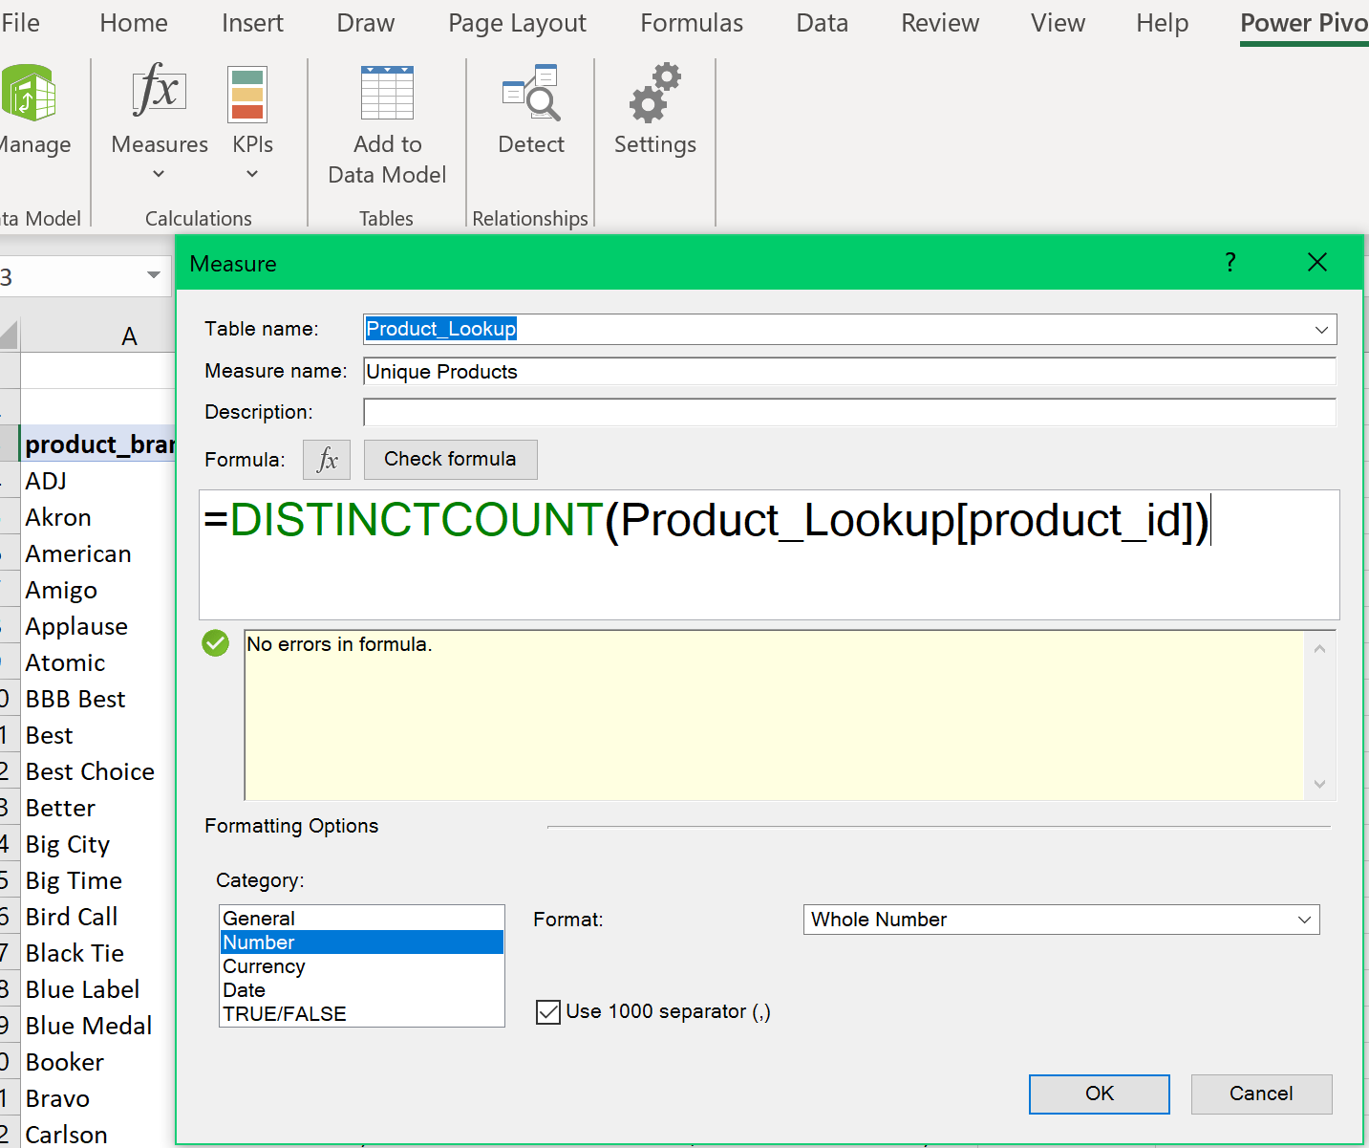



Here's your new view. Note the addition of "Unique Products" column.

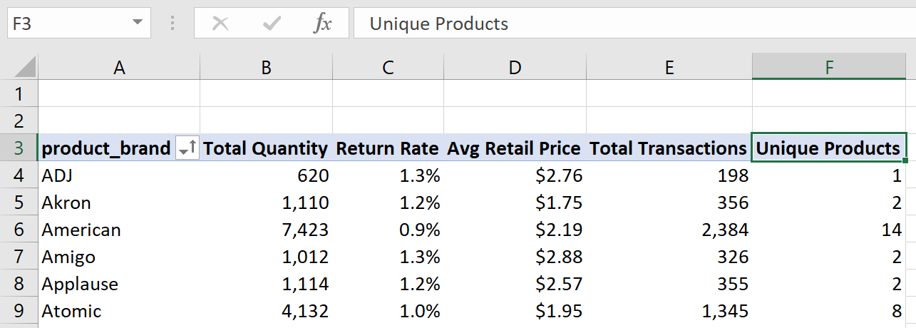

Selecting all the "Unique Products" values--Highlight the first data value cell under the "Unique Products" field. 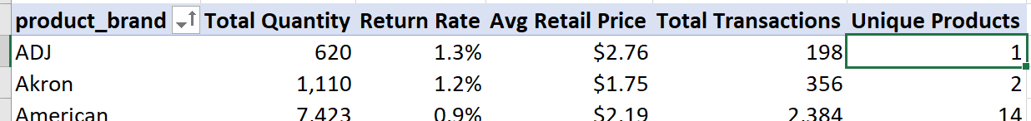

Hold down CTRL + SHIFT + arrow down to automatically highlight all the rows in the “Unique Products” column. Note that the last row was included. This is not desirable because this is the Grand Total line.

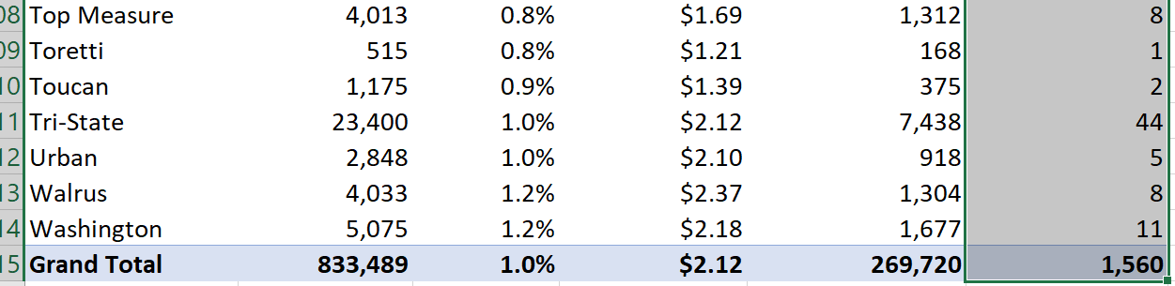

To mitigate this problem, release CTRL, keep holding SHIFT, and then press the arrow up once to exclude the last line.

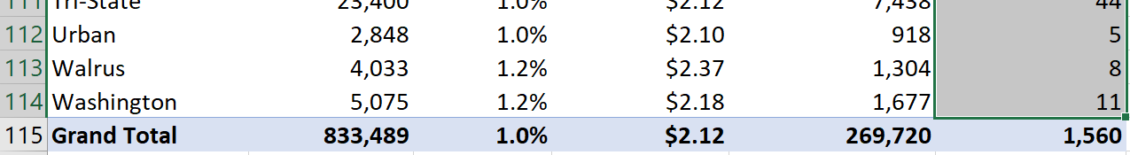

Please note that the Grand Total record is now excluded in the range selection.

Let's have fun! Go to formatting, Home > Conditional Formatting > Color Scale > Green-White scale.

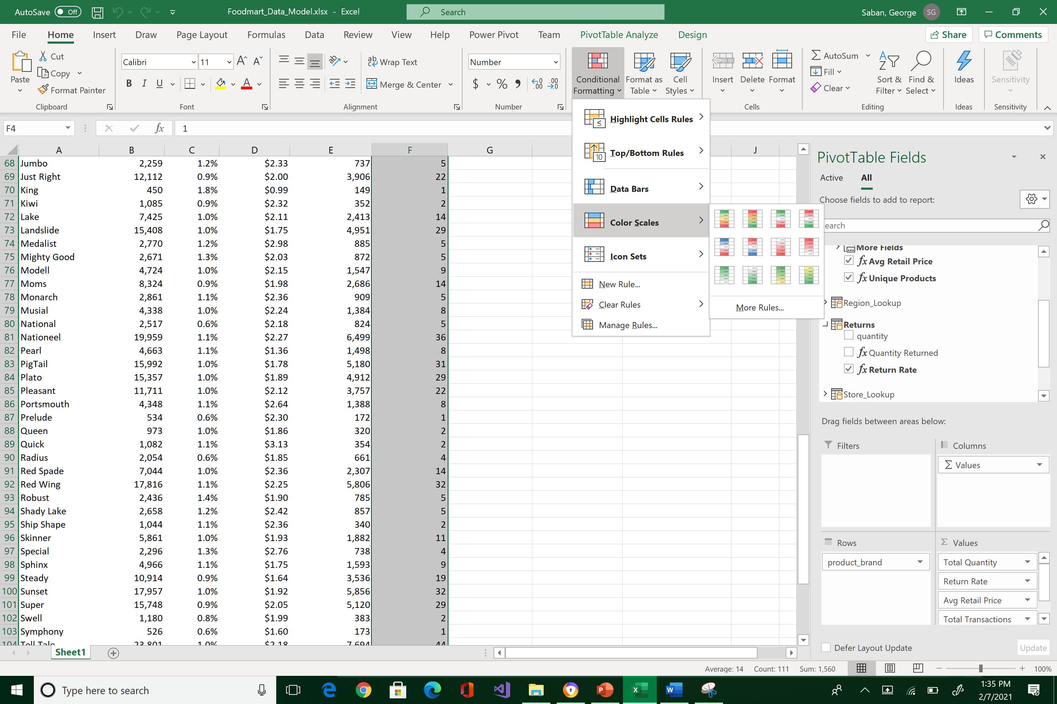



Observe the new graphical display below. This layout starts to draw attention to which products have fewer and larger counts.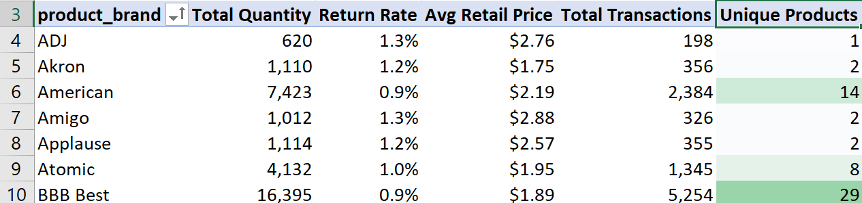

You can also use data bars formatting. For example, highlight all the cells under “Unique Products” column, clear first the previous formatting and then select the new format: Home > Conditional Formatting > Clear Rules > from selected cells > Conditional Formatting > Bars > Gradient Fill > Blue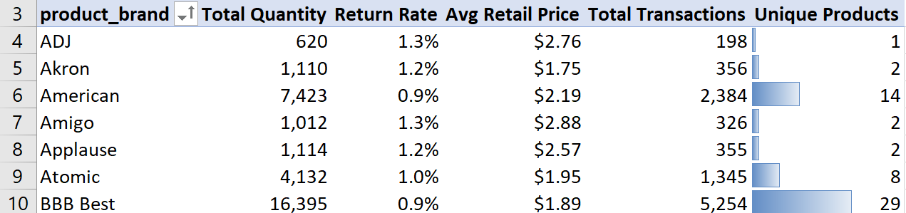

Now sort in descending order by unique products.

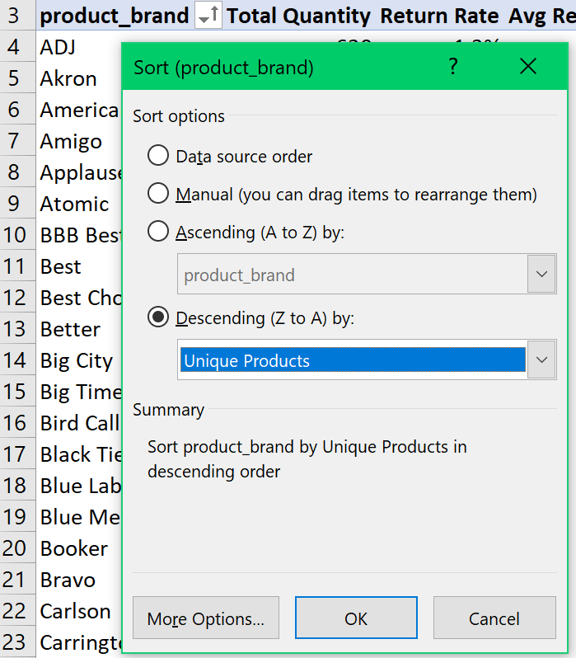



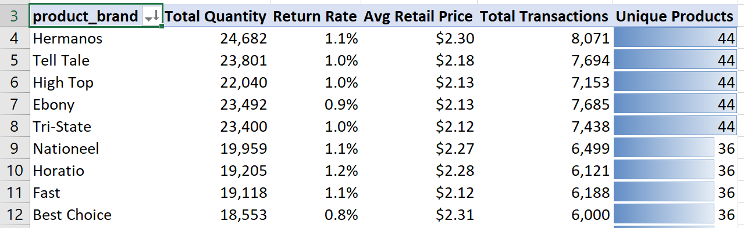

Scroll up and down to see the descending bars.

Let’s do one more measure using the COUNTA() function, which counts non-empty cells.

Call this measure “Recyclable Products” > assign to the product lookup table.

Remember that the product’s recyclable field contains the number 1 if it is recyclable, null if not. Also, use Tab to accept the fully-qualified field name.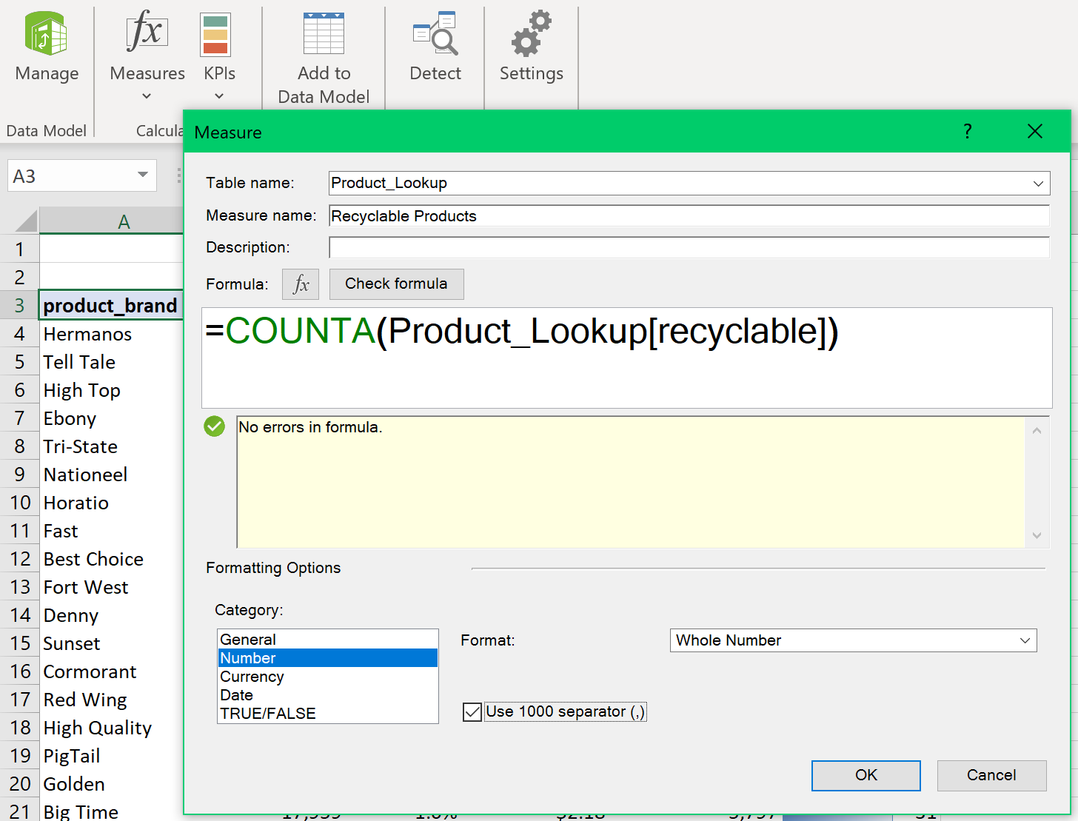



The new view of the pivot table will include “Recyclable Products.”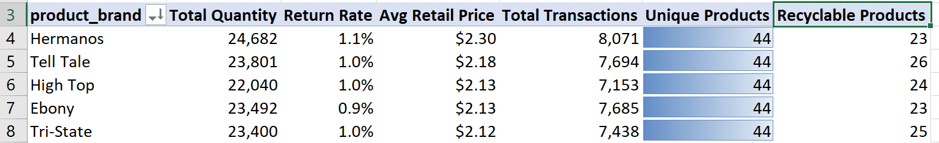

Remember to save early, save often, and backup your work.

What to submit? Please reposition your screens so that your pivot table would look like the image below.

1. Take a snapshot using Window's Snipping Tool.
2. Make sure the encircled items are included.
3. Submit to Canvas in PNG format.

Your efforts are greatly appreciated!

